LAB EXPERIMENT RECORD
Set 30: Mobile App Usage Analysis
Department | AIML
Course Code / Course Name | DSA0601 / Data Handling and Visualization
Experiment | Data Visualization using R
Name | HYDERABAD MOHAMMED NAWAZ
Register Number | 1925260144
Date | 22 October 2026
Day | Thursday
Aim
To import the Mobile_App_Usage dataset in R and visualize it using a histogram with density curve, a scatter plot with trend line and correlation, a bar chart of average satisfaction by gender, and a bubble chart with a usage-trend line chart.
Dataset: Mobile_App_Usage.csv
User_ID | Gender | Age | Screen_Time (hrs) | App_Usage_Count | Data_Used (GB) | Satisfaction | Usage_Date
U01 | Male | 20 | 4.5 | 18 | 2.4 | 3 | 2025-01-08
U02 | Female | 22 | 6 | 25 | 3.8 | 5 | 2025-01-08
U03 | Male | 19 | 3.2 | 12 | 1.6 | 3 | 2025-02-11
U04 | Female | 21 | 7.1 | 30 | 4.5 | 5 | 2025-02-11
U05 | Male | 23 | 2.8 | 10 | 1.2 | 2 | 2025-03-14
U06 | Female | 20 | 5.4 | 22 | 3.1 | 4 | 2025-03-14
PROGRAM 1: Histogram and Density Plot of Screen Time
Import the dataset in R. Plot a histogram and density plot for Screen_Time. Add suitable colors and labels. Interpret the screen-time distribution.
# Create the dataset
mobile <- data.frame(
User_ID = c("U01", "U02", "U03", "U04", "U05", "U06"),
Gender = c("Male", "Female", "Male", "Female", "Male", "Female"),
Age = c(20, 22, 19, 21, 23, 20),
Screen_Time = c(4.5, 6.0, 3.2, 7.1, 2.8, 5.4),
App_Usage_Count = c(18, 25, 12, 30, 10, 22),
Data_Used = c(2.4, 3.8, 1.6, 4.5, 1.2, 3.1),
Satisfaction = c(3, 5, 3, 5, 2, 4),
Usage_Date = as.Date(c(
"2025-01-08", "2025-01-08",
"2025-02-11", "2025-02-11",
"2025-03-14", "2025-03-14"
))
)

# Install ggplot2 only if not already installed
# install.packages("ggplot2")
library(ggplot2)

# Histogram with density curve
ggplot(mobile, aes(x = Screen_Time)) +
geom_histogram(
aes(y = after_stat(density)),
bins = 5,
fill = "skyblue",
color = "black",
alpha = 0.8
) +
geom_density(
color = "red",
linewidth = 1.2,
adjust = 1
) +
labs(
title = "Distribution of Mobile Screen Time",
x = "Screen Time (hours)",
y = "Density"
) +
theme_minimal()
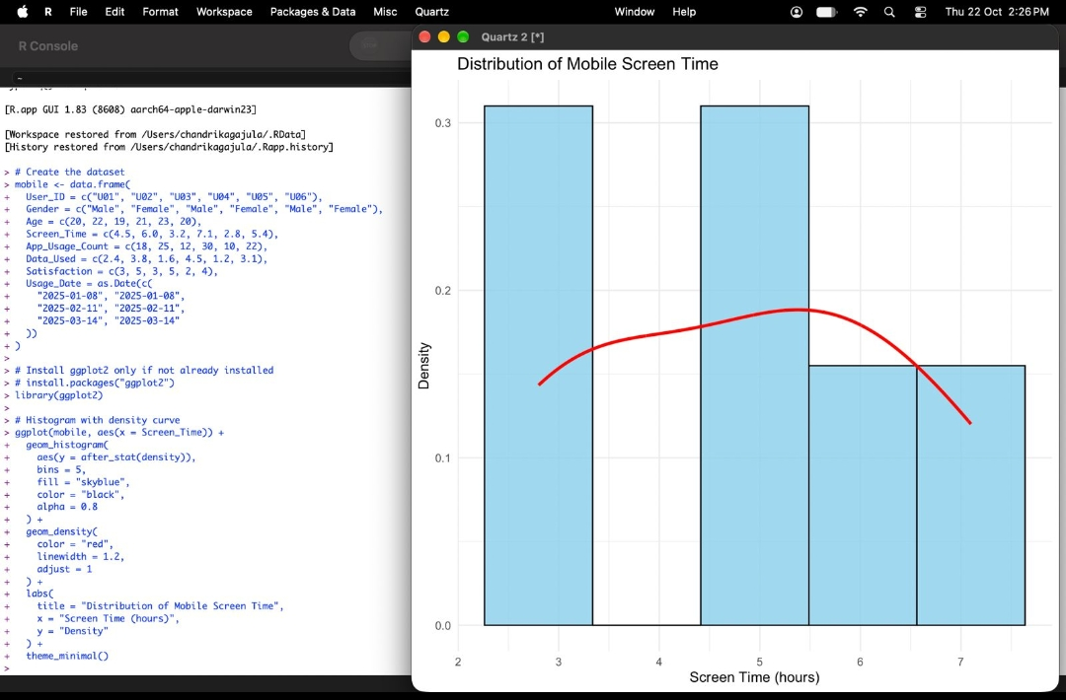
Output 1: Distribution of Mobile Screen Time (Histogram with Density Curve)
Interpretation: Screen time ranges from 2.8 to 7.1 hours with a mean of about 4.83 hours. The histogram has two tall bars (around 3 and 5 hours) and shorter bars at the higher end (6 to 7 hours), so most users spend between 3 and 6 hours on their mobile. The red density curve rises gently to a peak near 5 hours and then falls, showing that moderate usage is the most common while very high usage (above 6 hours) is rare. The distribution is fairly spread out and slightly right-skewed because of the 7.1-hour user.
PROGRAM 2: Scatter Plot of Data Used vs Screen Time
Create a scatter plot between Data_Used and Screen_Time. Calculate the correlation between them. Add a trend line. Explain the relationship.
# Scatter plot between Data Used and Screen Time
ggplot(mobile, aes(x = Data_Used, y = Screen_Time)) +
geom_point(
color = "blue",
size = 4
) +
geom_smooth(
method = "lm",
se = FALSE,
color = "red",
linewidth = 1
) +
labs(
title = "Screen Time vs Data Used",
x = "Data Used (GB)",
y = "Screen Time (hours)"
) +
theme_minimal()

# Calculate correlation
correlation <- cor(
mobile$Data_Used,
mobile$Screen_Time
)

print(correlation)
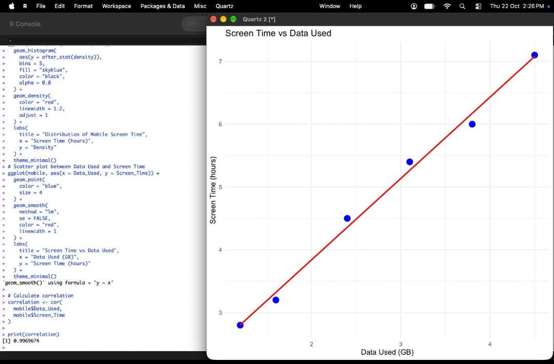
Output 2: Screen Time vs Data Used with Trend Line (Correlation = 0.9969674)
Explanation: The correlation coefficient is 0.9969674, which is very close to +1, indicating an extremely strong positive linear relationship. All six points lie almost exactly on the red regression line. As data usage increases from 1.2 GB to 4.5 GB, screen time increases from 2.8 to 7.1 hours. Users who spend more time on their screens therefore consume more mobile data. (Correlation shows association, not necessarily causation.)
PROGRAM 3: Average Satisfaction Score by Gender
Find the average Satisfaction score for each Gender. Create a bar chart for the averages. Add value labels. Interpret user satisfaction patterns.
# Calculate average satisfaction for each gender
avg_satisfaction <- aggregate(
Satisfaction ~ Gender,
data = mobile,
FUN = mean
)

# Display the average values
print(avg_satisfaction)

# Create bar chart with value labels
barplot(
avg_satisfaction$Satisfaction,
names.arg = avg_satisfaction$Gender,
col = c("skyblue", "pink"),
main = "Average Satisfaction Score by Gender",
xlab = "Gender",
ylab = "Average Satisfaction Score",
ylim = c(0, 5.5)
)

# Add value labels above the bars
text(
x = seq_along(avg_satisfaction$Satisfaction),
y = avg_satisfaction$Satisfaction,
labels = round(avg_satisfaction$Satisfaction, 2),
pos = 3
)

Console output:
Gender Satisfaction
1 Female 4.666667
2 Male 2.666667
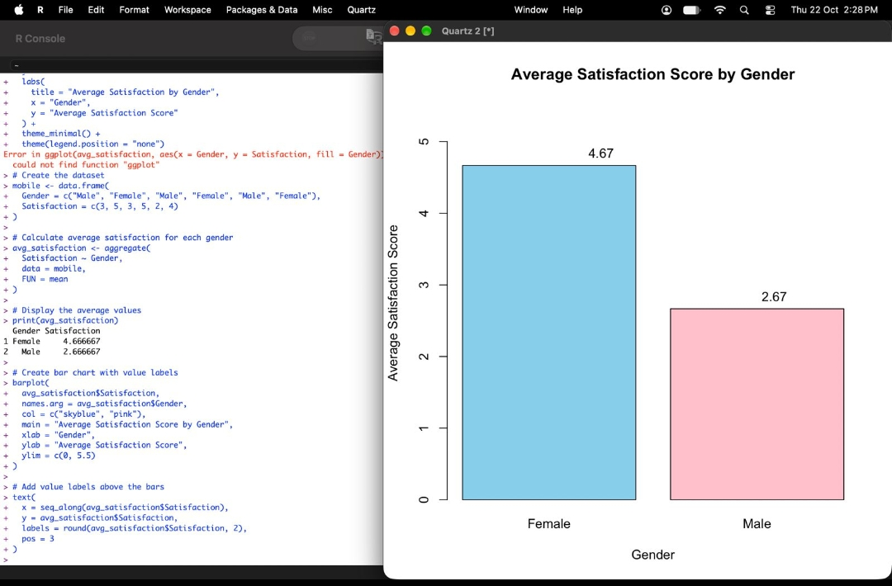
Output 3: Average Satisfaction Score by Gender (Bar Chart with Value Labels)
Interpretation: Female users have an average satisfaction score of 4.67, while male users have an average of 2.67, a difference of 2 points. Female users, who also record higher screen time and data usage, are clearly more satisfied with the mobile app experience, whereas male users show only moderate satisfaction. This suggests that heavier users in this sample tend to be more satisfied.
PROGRAM 4: Bubble Chart and Usage Trend
Import Mobile_App_Usage.csv. Create a bubble chart (Screen Time vs Data Used) using color for Gender and size for App Usage Count. Create a line chart for usage trends. Add filters for Gender and Usage_Date.
# Import dataset
mobile <- read.csv("Mobile_App_Usage.csv")
mobile$Usage_Date <- as.Date(mobile$Usage_Date)

screen <- mobile$Screen_Time
data <- mobile$Data_Used
apps <- mobile$App_Usage_Count
gender <- mobile$Gender
user <- mobile$User_ID
dates <- mobile$Usage_Date

par(mfrow = c(1, 2))

# Bubble chart
plot(screen, data,
pch = 19, cex = apps/10,
col = ifelse(gender == "Male", "blue", "red"),
xlab = "Screen Time",
ylab = "Data Used (GB)",
main = "Screen Time vs Data")

text(screen, data, labels = user, pos = 3)

legend("topleft", c("Male", "Female"),
col = c("blue", "red"), pch = 19)

# Usage trend
avg <- tapply(screen, dates, mean)
avg_dates <- as.Date(names(avg))

plot(avg_dates, as.numeric(avg),
type = "b", pch = 19, col = "darkgreen",
xlab = "Usage Date",
ylab = "Average Screen Time",
main = "Screen Time Trend")

par(mfrow = c(1, 1))
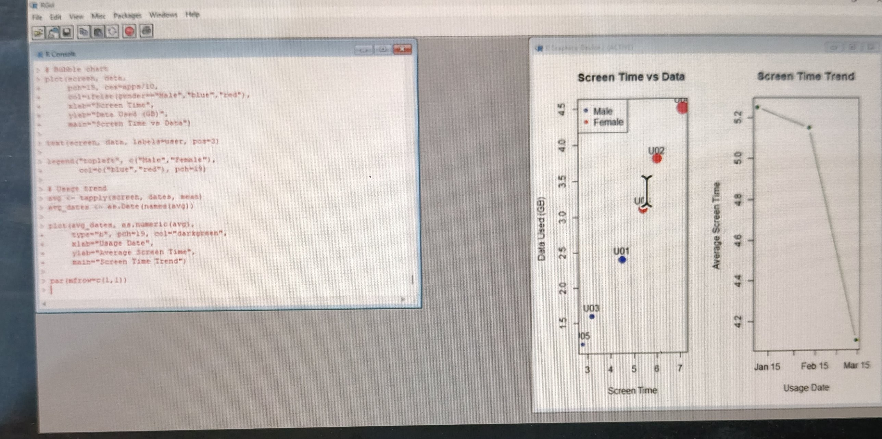
Output 4: Bubble Chart (Screen Time vs Data Used) and Screen Time Trend
Observation: In the bubble chart, blue bubbles represent male users and red bubbles represent female users, and bubble size shows the App Usage Count. Female users (U02, U04, U06) appear at the upper right with larger bubbles, meaning higher screen time, more data used and more apps used. Male users (U01, U03, U05) appear at the lower left with smaller bubbles. The trend line shows the average screen time falling from about 5.25 hours in January to about 4.2 hours in March, a steady decrease across the usage dates.
Filters: In Tableau, Gender and Usage_Date are added to the Filters shelf and shown as Gender (single/multiple value list) and Usage_Date (range or relative-date slider), so the bubble chart and trend line update interactively.
Procedure
1. Create the Mobile_App_Usage data frame (or import the CSV file) and load the ggplot2 package.
2. Use geom_histogram() with geom_density() to plot the Screen_Time distribution with colors and labels.
3. Use geom_point() and geom_smooth(method = "lm") to plot Data_Used vs Screen_Time, and cor() to compute the correlation.
4. Use aggregate() to find the mean Satisfaction for each Gender, then barplot() and text() to draw the bar chart with value labels.
5. Use plot() with cex = App_Usage_Count/10 and a color for Gender to build the bubble chart, and tapply() to compute the average screen time per date for the trend line.
Result
The Mobile App Usage dataset was successfully analysed and visualized in R using a histogram with density curve, a scatter plot with trend line (correlation = 0.997), a bar chart of average satisfaction by gender (Female = 4.67, Male = 2.67), and a bubble chart with a usage-trend line chart.
Key R Functions Used
Function | Purpose
ggplot() | Creates the base for ggplot2 graphics.
geom_histogram() / geom_density() | Draw the histogram and density curve.
geom_point() / geom_smooth() | Draw scatter points and the linear trend line.
cor() | Calculates the correlation coefficient.
aggregate() | Finds the average satisfaction for each gender.
barplot() / text() | Create the bar chart and add value labels.
tapply() | Computes average screen time for each usage date.

